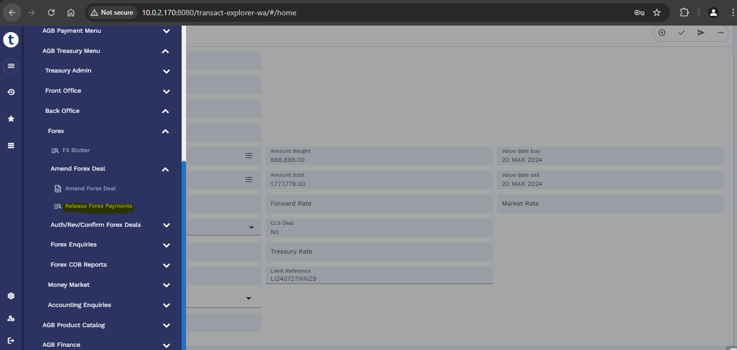
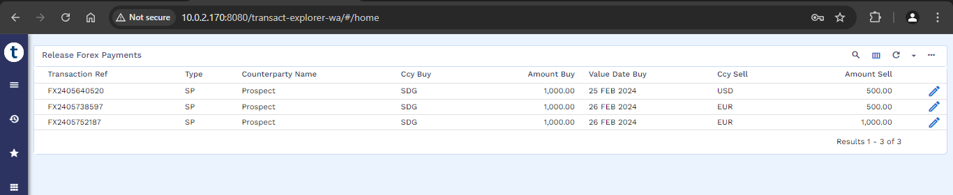
These are old records which are matured, hence cannot release forex payments.
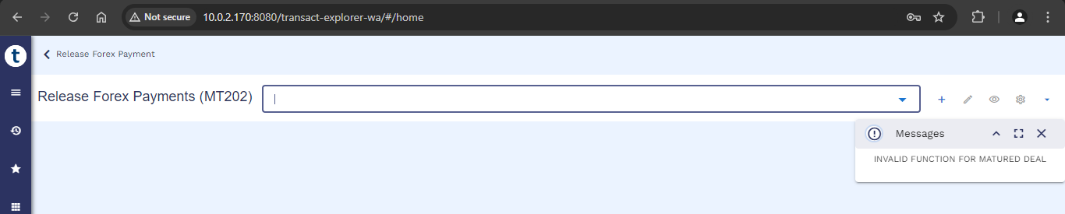
Many records were created in past few dates as below:
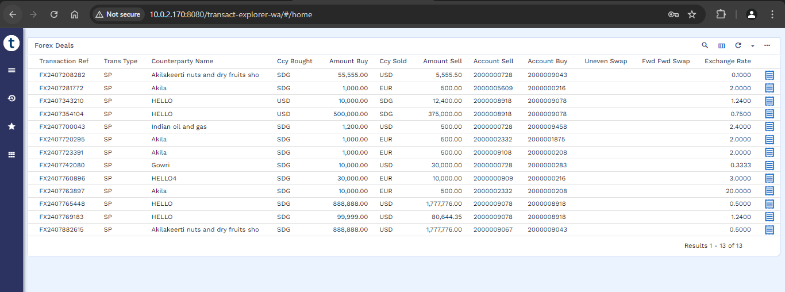

Example: the below record was created on 17th march 2024 but not reflected under “release forex payments”
